UNITED STATES
SECURITIES AND EXCHANGE COMMISSION
WASHINGTON, D.C. 20549
FORM 8-K
CURRENT REPORT
PURSUANT TO SECTION 13 OR 15(d) OF
THE SECURITIES EXCHANGE ACT OF 1934
DATE OF REPORT (DATE OF EARLIEST EVENT REPORTED)
October 29, 2024
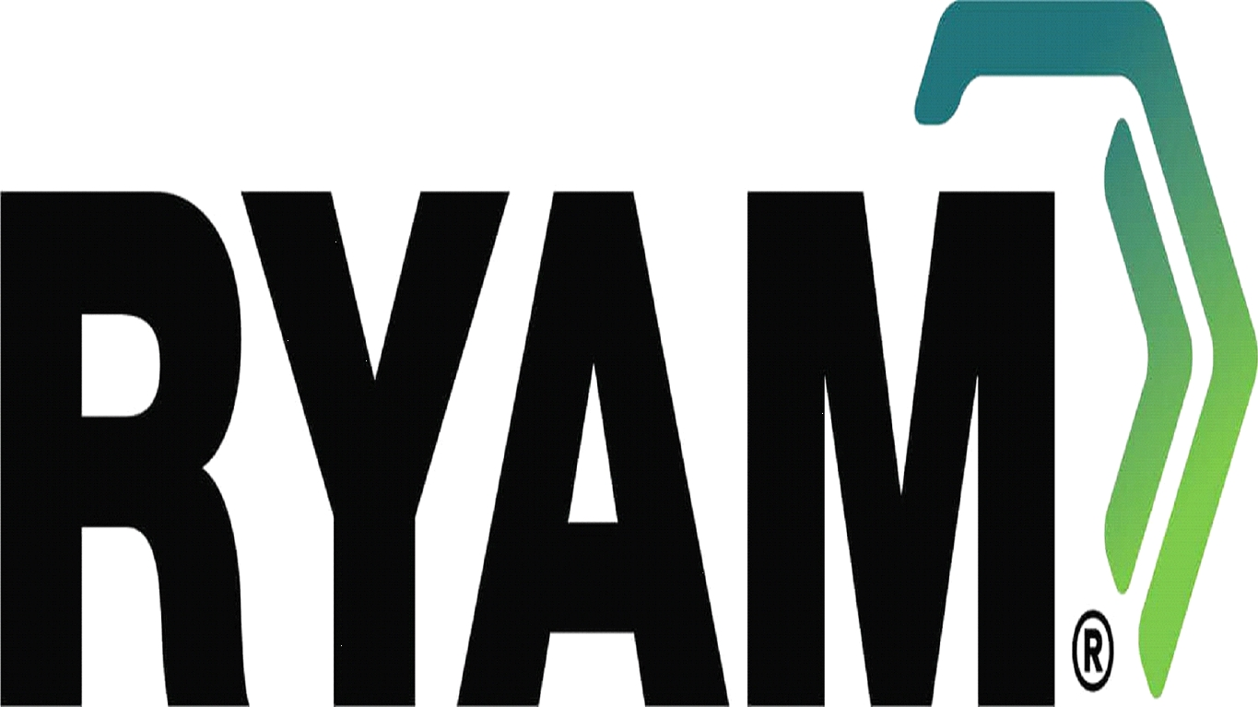
COMMISSION FILE NUMBER 001-36285
Incorporated in the State of Delaware
I.R.S. Employer Identification Number 46-4559529
Rayonier Advanced Materials Inc.
1301 Riverplace Boulevard, Jacksonville, Florida 32207
(Principal Executive Office)
Telephone Number: (904) 357-4600
Check the appropriate box below if the Form 8-K filing is intended to simultaneously satisfy the filing obligations of the registrant under any of the following provisions:
☐ | Written communications pursuant to Rule 425 under the Securities Act (17 CFR 230.425)

☐ | Soliciting material pursuant to Rule 14a-12 under the Exchange Act (17 CFR 240.14a-12)

☐ | Pre-commencement communications pursuant to Rule 14d-2(b) under the Exchange Act (17 CFR 240.14d-2(b))

☐ | Pre-commencement communications pursuant to Rule 13e-4(c) under the Exchange Act (17 CFR 240.13e-4(c))

Securities registered pursuant to Section 12(b) of the Act:
Title of Each Class | Trading Symbol | Name of Exchange on which Registered
Common Stock, $0.01 par value | RYAM | New York Stock Exchange

Indicate by check mark whether the registrant is an emerging growth company as defined in Rule 405 of the Securities Act of 1933 (§230.405 of this chapter) or Rule 12b-2 of the Securities Exchange Act of 1934 (§240.12b-2 of this chapter).
Emerging growth company ☐
If an emerging growth company, indicate by check mark if the registrant has elected not to use the extended transition period for complying with any new or revised financial accounting standards provided pursuant to Section 13(a) of the Exchange Act ☐

Item 7.01. | Regulation FD Disclosure.

On October 29, 2024, Rayonier Advanced Materials Inc. (the “Company”) issued a press release announcing that Rayonier A.M. Products Inc. (the “Issuer”), a wholly-owned subsidiary of the Company, has commenced a cash tender offer to purchase any and all of the Issuer’s outstanding 7.625% Senior Secured Notes due 2026. A copy of the press release is being furnished as Exhibit 99.1 to this Current Report on Form 8-K (this “Report”) and is incorporated herein by reference.

Item 9.01. | Financial Statements and Exhibits.

(d) Exhibits.
99.1 | Press release entitled “RYAM Announces Commencement of Cash Tender Offer for Any and All of Rayonier A.M. Products’ 7.625% Senior Secured Notes due 2026”
104 | Cover page interactive data file (embedded within the Inline XBRL document)

1

Signature

Pursuant to the requirements of the Securities Exchange Act of l934, the registrant has duly caused this Report to be signed on its behalf by the undersigned hereunto duly authorized.

Rayonier Advanced Materials Inc.
By: | /s/ R. Colby Slaughter
 | R. Colby Slaughter
 | Senior Vice President, General Counsel and Corporate Secretary
 | Date: October 29, 2024

Exhibit 99.1

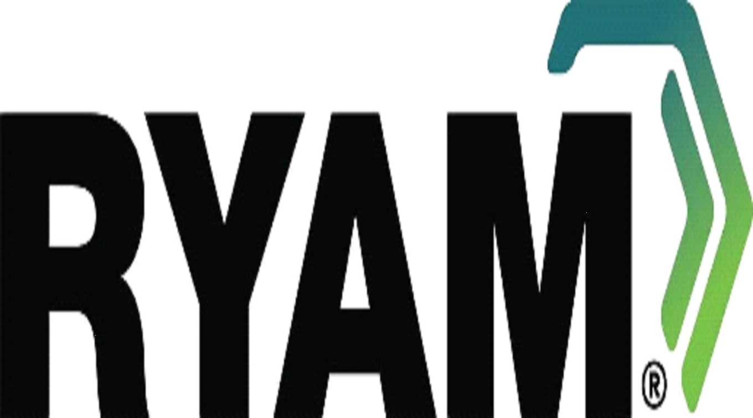

RYAM Announces Commencement of Cash Tender Offer for Any and All of Rayonier A.M. Products’ 7.625% Senior Secured Notes due 2026

JACKSONVILLE, Fla., October 29, 2024 — Rayonier Advanced Materials Inc. (NYSE: RYAM) (the “Company” or “RYAM”), the global leader in High Purity Cellulose, and its wholly-owned subsidiary, Rayonier A.M. Products Inc. (the “Issuer”), announced today that the Issuer has commenced a cash tender offer to purchase any and all of the Issuer’s outstanding 7.625% Senior Secured Notes due 2026 (the “notes”). As of October 29, 2024, the Issuer had $452,640,000 aggregate principal amount of notes outstanding.

The tender offer is being made pursuant to an offer to purchase, dated as of October 29, 2024 (as it may be amended or supplemented from time to time, the “Offer to Purchase”), and a notice of guaranteed delivery attached thereto (the “Notice of Guaranteed Delivery”). The tender offer will expire at 5:00 p.m., New York City time, on November 4, 2024, unless extended or earlier terminated as described in the Offer to Purchase (such time and date, as they may be extended, the “Expiration Date”).

Certain information regarding the notes is set forth in the table below.

Title of Security |  | CUSIP Numbers |  | Aggregate Principal Amount Outstanding
7.625% Senior Secured Notes due 2026 |  | 144A: 75508E AB4  Reg S: U75317 AB0 |  | $452,640,000

Holders of the notes who validly tender, and do not validly withdraw, their notes at or prior to the Expiration Date, or who deliver to the information and tender agent a properly completed and duly executed Notice of Guaranteed Delivery, in each case in accordance with the instructions described in the Offer to Purchase and the Notice of Guaranteed Delivery, will be eligible to receive for each $1,000 principal amount of notes accepted for purchase (1) $1,000 in cash as consideration and (2) a cash amount equal to accrued and unpaid interest from the last interest payment date up to, but not including, the settlement date, which is expected to occur on November 7, 2024. Tendered notes may be withdrawn at any time at or prior to the Expiration Date, or in the other circumstances set forth in the Offer to Purchase. The Issuer reserves the right to terminate, withdraw or amend the tender offer at any time, subject to applicable law.

The tender offer is subject to the satisfaction or waiver of certain conditions, including the Issuer’s completion of one or more debt financing transactions in an amount that is sufficient to fund the purchase of all of the outstanding notes and to pay all fees and expenses associated with such financing and the tender offer, as set forth in the Offer to Purchase. The tender offer is not conditioned on any minimum amount of notes being tendered. Additionally, the Issuer intends, but is not obligated, to legally defease all of its obligations under the outstanding notes that are not validly tendered and purchased in the tender offer pursuant to the terms of the indenture for such notes. However, there can be no assurance that such notes will be legally defeased.

The tender offer is being made pursuant to the terms and conditions contained in the Offer to Purchase and Notice of Guaranteed Delivery, and holders of the notes are urged to read the Offer to Purchase and Notice of Guaranteed Delivery carefully. Copies of the Offer to Purchase and Notice of Guaranteed Delivery may be obtained from Global Bondholder Services Corporation, the information and tender agent for the offer, by telephone at (855) 654-2015 (toll-free) or at (212) 430-3774 (banks and brokers only), by e-mail at contact@gbsc-usa.com or at the following web address: https://www.gbsc-usa.com/ryam/.

Persons with questions regarding the tender offer should contact the sole dealer manager: Houlihan Lokey Capital, Inc., by telephone at (888) 613-7288 (toll-free) or at (212) 497-7864.

None of the Company, the Issuer, the sole dealer manager, the information and tender agent, the trustee or the collateral agent for the notes, or any of their respective affiliates, is making any recommendation as to whether holders should tender any notes in response to the tender offer. Holders must make their own decision as to whether to tender any of their notes and, if so, the principal amount of notes to tender.

This press release is not an offer to purchase or a solicitation of an offer to sell any securities and does not constitute a redemption notice or notice of defeasance or satisfaction and discharge for any securities. The tender offer is being made solely by means of the Offer to Purchase and Notice of Guaranteed Delivery and only in such jurisdictions as is permitted under applicable law.

About RYAM

RYAM is a global leader of cellulose-based technologies, including high purity cellulose specialties, a natural polymer commonly used in the production of filters, food, pharmaceuticals and other industrial applications. RYAM’s specialized assets, capable of creating the world’s leading high purity cellulose products, are also used to produce biofuels, bioelectricity and other biomaterials such as bioethanol and tall oils. The Company also manufactures products for paper and packaging markets. With manufacturing operations in the U.S., Canada and France, RYAM generated $1.6 billion of revenue in 2023. More information is available at www.RYAM.com.

Contacts

Media | Ryan Houck | (904) 357-9134
Investors | Mickey Walsh | (904) 357-9162

Forward-Looking Statements

Certain statements in this document regarding anticipated financial, business, legal, or other outcomes, including business and market conditions, outlook, and other similar statements relating to RYAM’s or the Issuer’s future or expected events, developments, or financial or operational performance or results, are "forward-looking statements" made pursuant to the safe harbor provisions of the Private Securities Litigation Reform Act of 1995 and other federal securities laws. These forward-looking statements are identified by the use of words such as "may," "will," "should," "expect," "estimate," "believe," "intend," "anticipate," and other similar language. However, the absence of these or similar words or expressions does not mean that a statement is not forward-looking. While we believe these forward-looking statements are reasonable when made, forward-looking statements are not guarantees of future performance or events, and undue reliance should not be placed on these statements. Although we believe the expectations reflected in any forward-looking statements are based on reasonable assumptions, we can give no assurance that these expectations will be attained. It is possible that actual results may differ materially from those indicated by these forward-looking statements due to a variety of risks and uncertainties.

Other important factors that could cause actual results or events to differ materially from those expressed in forward-looking statements that may have been made in this document are described or will be described in our filings with the U.S. Securities and Exchange Commission, including our Annual Report on Form 10-K and Quarterly Reports on Form 10-Q. RYAM and the Issuer assume no obligation to update these statements except as is required by law.

