UNITED STATES
SECURITIES AND EXCHANGE COMMISSION
WASHINGTON, D.C. 20549
FORM 8-K
CURRENT REPORT
PURSUANT TO SECTION 13 OR 15(d) OF
THE SECURITIES EXCHANGE ACT OF 1934
DATE OF REPORT (DATE OF EARLIEST EVENT REPORTED)
September 8, 2024
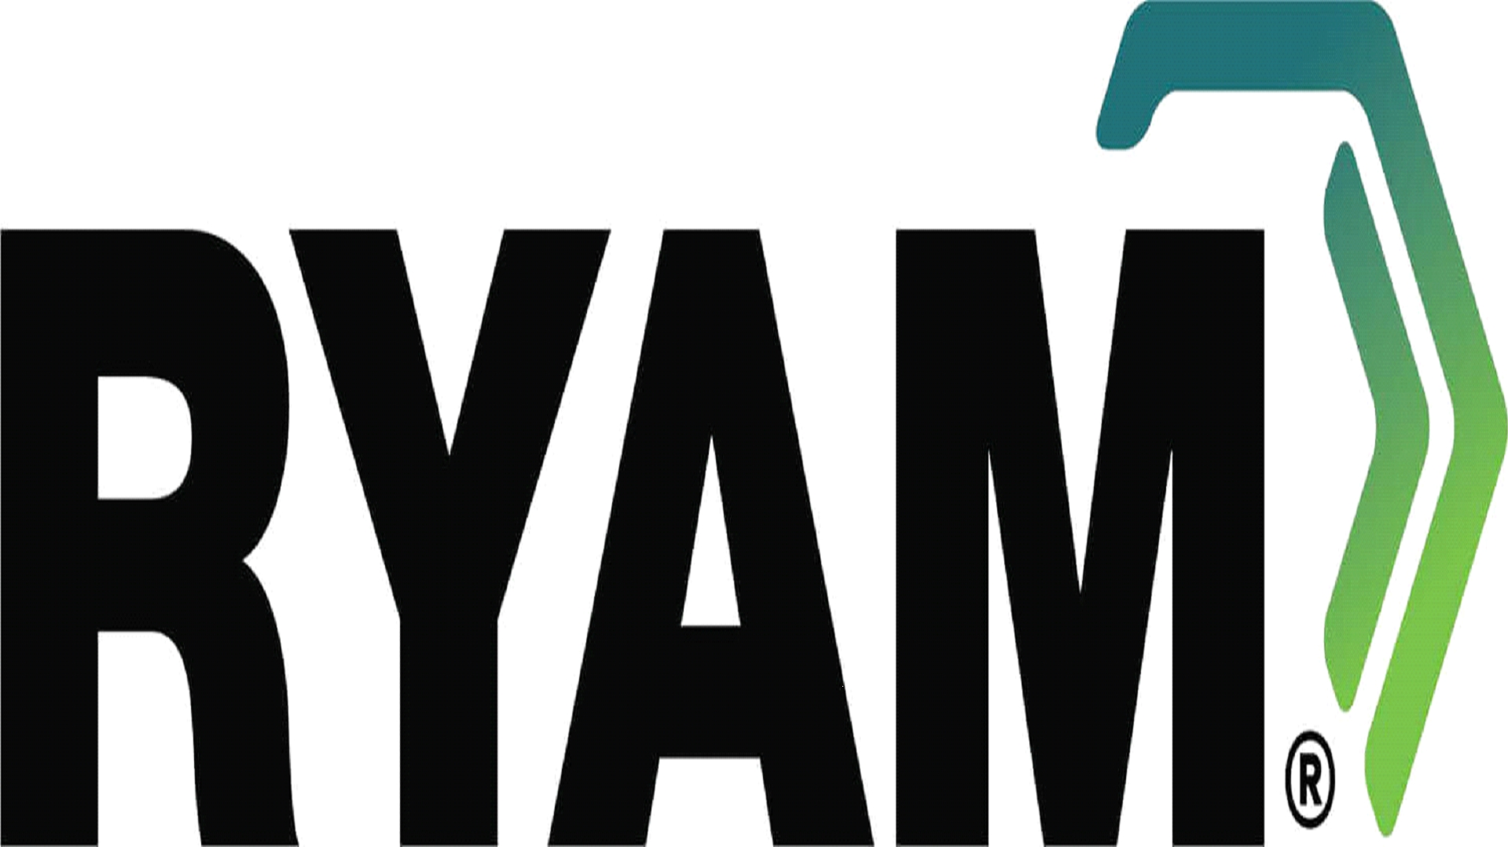
COMMISSION FILE NUMBER 001-36285
Incorporated in the State of Delaware
I.R.S. Employer Identification Number 46-4559529
Rayonier Advanced Materials Inc.
1301 Riverplace Boulevard, Jacksonville, Florida 32207
(Principal Executive Office)
Telephone Number: (904) 357-4600
Check the appropriate box below if the form 8-K filing is intended to simultaneously satisfy the filing obligations of the registrant under any of the following provisions:
☐ | Written communications pursuant to Rule 425 under the Securities Act (17 CFR 230.425)

☐ | Soliciting material pursuant to Rule 14a-12 under the Exchange Act (17 CFR 240.14a-12)

☐ | Pre-commencement communications pursuant to Rule 14d-2(b) under the Exchange Act (17 CFR 240.14d-2(b))

☐ | Pre-commencement communications pursuant to Rule 13e-4(c) under the Exchange Act (17 CFR 240.13e-4(c))

Securities registered pursuant to Section 12(b) of the Act:
Title of Each Class | Trading Symbol | Name of Exchange on which Registered
Common Stock, $0.01 par value | RYAM | New York Stock Exchange

Indicate by check mark whether the registrant is an emerging growth company as defined in Rule 405 of the Securities Act of 1933 (§230.405 of this chapter) or Rule 12b-2 of the Securities Exchange Act of 1934 (§240.12b-2 of this chapter).
Emerging growth company ☐
If an emerging growth company, indicate by check mark if the registrant has elected not to use the extended transition period for complying with any new or revised financial accounting standards provided pursuant to Section 13(a) of the Exchange Act ☐

Item 5.02. | Departure of Directors or Certain Officers; Election of Directors; Appointment of Certain Officers; Compensatory Arrangements of Certain Officers

Item 5.02(b) | Departure of Directors or Certain Officers

Charles E. Adair tendered his resignation from the Board of Directors (the “Board”) of Rayonier Advanced Materials Inc. (the “Company”) effective 11:59 p.m. (EDT) on September 8, 2024. Mr. Adair’s resignation is due to personal reasons and does not involve any disagreement on any matter relating to the Company’s operations, policies or practices.

Item 5.02(d) | Election of Directors

Effective September 9, 2024, the Company’s Board elected Eric M. Bowen as a Class I independent director of the Company to serve until the 2027 annual meeting of the stockholders of the Company and thereafter until his successor has been duly elected and qualified, or until his earlier death, resignation or removal. Effective September 9, 2024, Mr. Bowen was also appointed to each of the Audit Committee and the Sustainability Committee of the Board. There are no arrangements or understandings between Mr. Bowen and any other person pursuant to which he was selected as a director. In addition, there are no transactions in which Mr. Bowen has an interest that would require disclosure under Item 404(a) of Regulation S-K.

Upon his election to the Board, Mr. Bowen will receive compensation equivalent to the compensation of the other non-employee directors (as described in the Company’s most recent Proxy Statement filed with the SEC), except that Mr. Bowen will receive a prorated 2024-2025 annual cash retainer and a prorated number of restricted stock units of the Company, to vest on the earlier of the first anniversary of the date of grant or the next annual meeting of the stockholders at which one or more members of the Board are standing for re-election, as long as Mr. Bowen has not voluntarily left the Board prior to such date. Additionally, in connection with Mr. Bowen’s election to the Board, the Company and Mr. Bowen will enter into an indemnification agreement in substantially the same form that the Company has entered into with each of the Company’s existing directors. The form of such indemnification agreement was previously filed by the Company as an exhibit to its Amendment No. 4 to the Registration Statement on Form 10 filed with the SEC.

Item 9.01. | Financial Statements and Exhibits.

A copy of the press release announcing the election of Mr. Bowen is furnished herewith as Exhibit 99.1.

99.1 | Press release entitled “RYAM Elects Eric M. Bowen to the Board of Directors”
104 | Cover page interactive data file (embedded within the Inline XBRL document)

1

Signature

Pursuant to the requirements of the Securities Exchange Act of l934, the registrant has duly caused this Report to be signed on its behalf by the undersigned hereunto duly authorized.

Rayonier Advanced Materials Inc.
By: | /s/ R. COLBY SLAUGHTER
 | R. Colby Slaughter
 | Senior Vice President, General Counsel and Corporate Secretary
 | Date: September 9, 2024

Exhibit 99.1



 | For Immediate Release | 

Contacts:
Media | Ryan Houck | 904-357-9134
Investors | Mickey Walsh | 904-357-9162

RYAM Elects Eric M. Bowen to the Board of Directors

JACKSONVILLE, Fla. – September 9, 2024 -- Rayonier Advanced Materials Inc. (NYSE: RYAM) (the “Company”) announced today that Eric M. Bowen has been elected to its Board of Directors, effective September 9, 2024.

“We are pleased to welcome Eric to our Board of Directors and look forward to the benefit of his insight, experience and expertise,” stated Lisa M. Palumbo, Non-Executive Chair of the Company's Board of Directors. “His more than 20 years of experience in the biofuels industry, along with his knowledge of energy transition and the renewable products market will bring significant value to our Board and stockholders.”

Mr. Bowen currently serves on the Advisory Board of Terviva, Inc., a private California company developing a novel tree crop for biofuel, feed and food markets. He held a number of roles at Renewable Energy Group, Inc. (NASDAQ: REGI) from 2010 through its sale in June 2022. He most recently served as General Counsel, Corporate Secretary, and Vice President of Strategy, from April 2020 through June 2022, where he was instrumental in growing the company’s renewable diesel business and completing the sale of REGI to Chevron Corporation. Prior to that, in his capacity as Vice President, Corporate Business Development & Legal Affairs from January 2013 to April 2020, Mr. Bowen positioned the company into emerging decarbonization markets, including renewable diesel. He also served as head of the REGI Life Sciences business unit from January 2014 until its sale in May 2019. Prior to his tenure with REGI, Mr. Bowen served as Founder, President and CEO of Tellurian Biodiesel, Inc., a leading California waste-based, low-carbon fuel company that was acquired by REGI in 2010.

Mr. Bowen has served as a member of various boards of directors during his career, including most recently with Forge Hydrocarbons from November 2013 to October 2022, and with Hydrogen Works from December 2021 through July 2024.

He holds a J.D. from the University of California, Berkeley and a B.A. from the University of Oregon Honors College.

About RYAM

RYAM is a global leader of cellulose-based technologies, including high purity cellulose specialties, a natural polymer commonly used in the production of filters, food, pharmaceuticals, and other industrial applications. The Company also manufactures products for paper and packaging markets. With manufacturing operations in the U.S., Canada, and France, RYAM generated an estimated $1.6 billion of revenue in 2023. More information is available at www.RYAM.com

